**Country Program**

Cambodia

**Accused**

Name: Phou San

Photo:

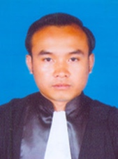

Physical Description: 167 cm, 63 kg

Distinguishing Features: Scar on elbw 🡨 intentional typo, is there a way to fix?

Date of Birth: May 22, 1991

Age: 27 years old

Sex: Male

Place of Residence: 100 Sihanouk Boulevard, Phnom Penh

Occupation: Translator

**Arrest**

Date of Arrest: March 2, 2016

Location of Arrest: Sre Thmey Hotel

Arresting Officer: Phnon Penh Police, District 3

Crime being accused off: Rape

**Accuser**

Name: Sue Yang

Age: 21

Sex: Female

Other Details: Chinese

**Detention**

Current Detention: Prey Sa Prison

Detention Center Contact: Sophea Phan

Special Note: Need careful tracking, we’ve found lost inmates here in the past.

Moved here: April 4, 2017

Signs of Torture: N/A

Previous Detention: Phnon Penh Police, District 3

Detention Center Contact: N/A

Special Note: police in this district known for aggression

Moved here: March 2, 2017

Signs of Torture: Visible bruise on right cheek

**Status**

Trial Date: was on March 21, 2017

Detention: since March 2, 2016

Sentencing Terms: at least 4 years, maximum 8 years

Release Date: earliest March 3, 2020

**Public Defender**

Name:Sami Pheakdey

Photo:

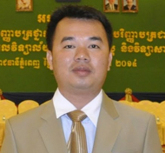

Affiliation: IBJ Pro Bono Lawyer

**Prosecutor**

Name: Chak Phan

Special Note: no relation to Prey Sa Prison contact

**Judge Assigned to Case**

Trial Judge: Judge not yet assigned

Special Note: N/A

**Case Contact**

Name: Mae San

Affiliation with Accuse: Wife

Contact Information: +855 866514474

Address: 100 Sihanouk Boulevard, Phnom Penh

First Contact: approached CBJ Phnom Penh office on March 4, 2016

Last updated on accused status: November 2, 2017

*Emergency Contact*

Name: N/A

Affiliation with Accuse: N/A

Contact Information: N/A

Address: N/A

Special Note: wife MIA since November 2017

**IBJ Case Supervisor**

Name: Sophea Da

Affiliation: Volunteer Curator, Cambodia Bridges to Justice

Contact Information: +855 23516992, dar_cam3@yahoo.com

Last log-in: December 9, 2018